PRESS KIT

Promotica S.p.A. is a leading loyalty marketing company in Italy

Extensive experience gained in the retail, food, pharmaceutical, oil and service sectors

TABLE OF CONTENTS

- OVERVIEW OF THE GROUP page 3
- COMPANY HISTORY page 3
- ACQUISITIONS page 6
- SERVICES page 7
- CAMPAIGN TYPE page 8
- CUSTOMERS page 9
- KEY FINANCIALS page 10
- SUSTAINABILITY REPORT page 10
- CORPORATE STRUCTURE AND OWNERSHIP page 11
- MANAGEMENT page 12

OVERVIEW OF THE GROUP
Promotica is a leading loyalty marketing company in Italy. Established in 2003 by Diego Toscani and listed on the Italian stock exchange's Euronext Growth Milan market since 27 November 2020, the company has gained considerable experience in loyalty marketing over the years, making it the ideal partner for planning, organising and managing all types of marketing operations that focus on customer loyalty. Promotica provides a full consultancy service for promotional planning and development, managing the constituent phases involved, such as planning promotional activities, implementing communication campaigns, supplying rewards, logistics services, monitoring data and measuring results. The aim of the marketing operations is to increase sales, customer loyalty and brand advocacy.
Promotica creates tailor-made loyalty schemes that achieve real measurable results in terms of sales and market share.
The company boasted 107 active customers in 2021, with the implementation of 249 promotional campaigns. During its time in business it has worked with more than 1800 customers.

COMPANY HISTORY
Promotica was established in 2003 by Diego Toscani in Desenzano del Garda (BS). The quality of its service was quickly rewarded and major partnerships soon transpired with industrial customers and operators belonging to the retail industry (Galbani and Gruppo VeGè), with the company appointed to manage their loyalty schemes.
The main events that have characterised the growth of the group over the years are as follows:

2004
Promotica becomes a full loyalty scheme service provider and is no longer just a marketing agency. This expansion is possible thanks to targeted investment in personnel and technological support. The company starts offering campaign promotion services and in-store communication tools. Company development continues in the coming years, with an increase in services and an extended product range, until 2011 when national customers are acquired with the initiation of campaigns with Coop and Crai.
2012
A new branch opens in Sarezzo (BS) dedicated to the creation of advertising campaign materials by the company's designers.
2015
Company reorganisation commences, involving the creation of a more structured management team, the production of catalogues to offer customers, and the search for exclusive brands for the supply and development of new complementary products.
2017
Promotica purchases the development licence for the Roialty One Experience platform to create, manage and monitor online loyalty schemes.
2018
The internationalisation process commences with the acquisition of an external agent to manage the Eastern European market, based in Belgrade, and an agent dedicated to developing the Asia-Pacific market, based in Hong Kong.
2020
On 27 November 2020 Promotica is listed on the Italian stock exchange's Euronext Growth Milan market, specifically for SMEs with high growth potential.
2021
Promotica is a 4-time winner in the Promotion Awards 2021, which annually rewards the best engagement and loyalty campaigns which have stood out in Italy's promotional market.
The 4 awards won by Promotica are as follows:
- Best catalogue award for Raccolta Punti 2020 La collezione che guarda al future (2020 points collection looking to the future) for Coop Alleanza 3.0.
- Best short-term collection with Colleziona buone abitudini (Good habits collection) for Conad.
- Best multichannel campaign with BeAppy 2.0, implemented with Coop Centro Italia with the aim of designing a relationship tool between associates and the Cooperative.
- Special mention from the judging panel as Best Catalogue for Catalogo Premi per te 2020 (2020 reward catalogue for you) created for C+C, the national emblem of the Selex Group dedicated to the cash and carry sector.
Promotica attends the HOMI – The Lifestyle event with the Ki-Life stand by Kiki Lab (Promotica Group) dedicated to sustainability. This trade fair, held in September at Fiera Milano in conjunction with Milan Design Week 2021, is a showcase for companies to illustrate their innovative products and designs to meet the latest lifestyle requirements, and to outline new frontiers in contemporary living.
2022
Promotica is a 3-time winner in the Promotion Awards 2022, which annually rewards the best engagement and loyalty campaigns which have stood out in Italy's promotional market.
- Best Retail Reward Catalogue with the catalogue Siamo quello che scegliamo (We are what we choose) made for Coop Alleanza 3.0. The main aim of this campaign is to establish an ongoing clear and intuitive link between the sustainability aspects of the rewards in the catalogue i.e. green, made in Italy, solidarity, and those same characteristics in Coop branded products.
- Best Communication and Storytelling with Brandani Linea Acquarello at Unicoop Firenze: up for grabs is a high-quality ceramic table, decorated by hand with lead-free paints and enamels to safeguard the environment, and made by craft designers from the historic ceramic district of Civita Castellana (VT). Thanks to the collaboration between Promotica, Unicoop Firenze and Brandani, the campaign is a success and helps considerably to regenerate the fortunes of an excellent craft production area at serious risk of becoming redundant.
Special Mention Edutainment Category with the Diamo un’alimentazione migliore a tutti i bambini che non ce l’hanno (A Healthy Diet for Needy Children) initiative for the customer Italmark, in an innovative campaign designed to help children and families. Loyalty is intertwined with support to help children in hardship, by donating to the food bank. Collecting points can lead to winning the MiniGreeny cuddly toys that look like fruit and vegetables, in order to encourage a healthy diet, and which are made of environmentally-friendly materials.
In May 2022 MAPS, an innovative SME in the digital transformation industry, signs a licence agreement with PROMOTICA for the exclusive international use of the Roialty platform in the customer loyalty market. Furthermore, as part of the agreement, PROMOTICA acquires 100% ownership of the Roialty brand.

ACQUISITIONS
KIKI LAB - In 2020 Promotica took over Kiki Lab, a consultancy firm specialising in retail innovation and retail of the future. Kiki Lab is a member of the Ebeltoft Group, a global alliance of 18 retail consultancy firms. The takeover enabled Promotica to bring Kiki Lab expertise into scope, extend its reference market, and capitalise on the international character of the company, which changed its legal form in June from being a limited liability company (S.r.l.) to a joint stock company (S.p.A.). This change represents a major achievement for Promotica, and is a natural development following progressive company growth in recent years, as well as being a launch pad for further business development.

GRANI & PARTNERS - In November 2021 Promotica acquired an 80% share in the company Grani & Partners from Giochi Preziosi. The stake in this international player means Promotica can extend its geographical presence and sector coverage, developing its loyalty offering to the children's sector, automotive and production industries, and consolidating its presence at an international level, especially in Asia.
Following this operation Giochi Preziosi S.p.A. announced that it had become part of Promotica's share capital on 17 January 2022 via the transfer from Dieci.Sette S.r.l. of 500,000 ordinary Promotica shares to Giochi Preziosi S.p.A.

GIGLIO GROUP LOYALTY & INCENTIVE BUSINESS - In February 2022 Promotica took over Giglio Group's Loyalty & Incentive business, further reinforcing its position in the loyalty marketing sector as a company that uses cutting-edge digital engagement tools.

MERCATI S.R.L. - In June 2022 Promotica signed a framework agreement to acquire 100% control of Mercati S.r.l., an Italian company that produces homeware and lifestyle items. This takeover enables the company to extend its value chain by internalising production and the process of importing items to be used for promotional campaigns. Moreover, Mercati has well-established relationships with production facilities in Italy and abroad, with positions of interest in the Far East, opening up new expansion opportunities for Promotica. Another of Mercati's strengths is that it specialises in the retail trade and special make-up market, representing new business channels for Promotica's loyalty marketing business.

SERVICES
Promotica offers a 360° range of services for the implementation of marketing campaigns, guaranteeing advice and professionalism in managing all phases of the promotional process to increase sales through customer loyalty, improve brand advocacy and increase share of wallet. Communication, graphic design, web design, media planning and public relations activities are combined by Promotica to create one ad hoc campaign for customers, defining the product category and most appropriate selling mix. Furthermore, Promotica manages storage logistics, reward distribution and unsold goods, which are reused in new campaigns, keeping returns to a minimum. The structure of the internal business intelligence obtained from the Roialty One Experience platform, the IT Syneto system and big data analysis, enables improvements to the design and progress of campaigns, in addition to user profiling and the personalisation of the user experience to support brand awareness through customer engagement.

CAMPAIGN TYPE
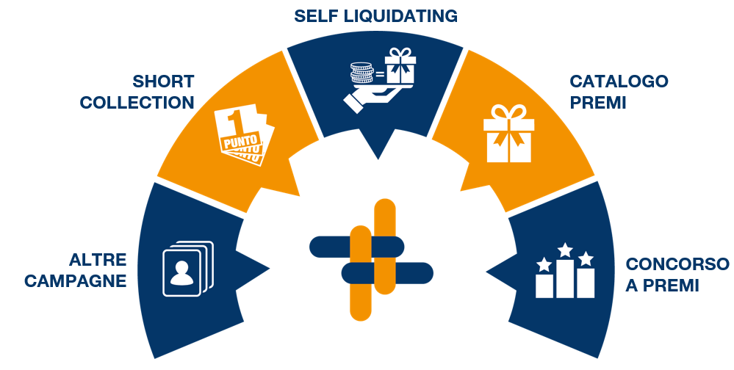

- Short-term collection: mini collection of rewards achievable by the customer collecting stamps and a possible cash payment. Reward campaigns lasting 12 to 16 weeks.
- Self liquidating: campaigns with immediate rewards, also known as 'spend & get', lasting 4 to 8 weeks. When paying for shopping and reaching a minimum spend threshold, customers receive a reward immediately in exchange for a small payment.
- Reward catalogue: mixed mechanism with redemption exclusively through digital points or with digital points plus a cash payment. Almost always multi-category with a high number of rewards (on average 100 items available to customers). Lasts between 1 and 5 years on average.
- Reward competitions: Similar to a lottery where a jackpot is guaranteed by the promoter and wins are linked to luck or participant ability. Variable duration, typically from a week to a year.
- Miscellaneous: Special promotions with rewards of lower commercial value but high emotional value, mainly targeted at children; B2B incentives aimed at professionals.
CUSTOMERS
Promotica's customers include some of the biggest names in food retail (86% of turnover) and major companies in the pharmaceutical, bank, insurance and oil industries (14% of turnover) in Italy and abroad. Some major customers are outlined below:

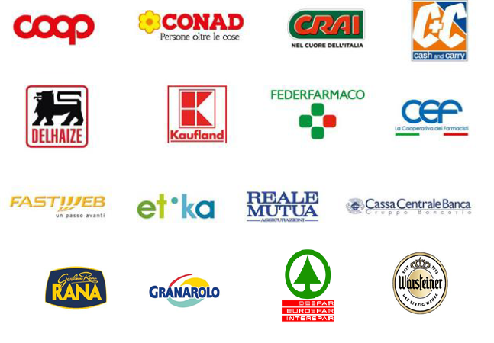

KEY FINANCIALS
Results in 2021 reflected the international economic situation with issues concerning supply chains and transport costs, both affected by lengthy lockdowns during the pandemic. In 2021 consolidated turnover was €39.6 million compared with €57.0 million in 2020. This result reflects the shift of some national campaigns to 2022, due to issues with sourcing products at sustainable costs during the financial year, and delivery timescales for the products themselves.
With regard to margins, EBITDA was €2.0 million, with a margin of 5.2% compared with 12.0% in the previous financial year. Margins suffered from the general increase in all major cost items and their effect, which couldn't be passed on to the end customer for campaigns already agreed in 2021. These cost increases were passed on to campaigns initiated in 2022, which were repriced.
The Net Result as at 31 December 2021 was positive at €1.4 million.
Finally, net worth was valued at €12.3 million, an improvement compared with €11.8 million on 31 December 2020.

SUSTAINABILITY REPORT
Promotica's strong sense of responsibility and transparency when it comes to ESG topics resulted in the company publishing a 2021 Sustainability Report, which was the first in the company's history. It was produced voluntarily and approved by the Board of Directors on 18 May 2022.
The report was drawn up in accordance with the core 102-54 option of the GRI Sustainability Reporting Standards (GRI Standards), without being reviewed by an independent party however. The scope of the report is the entire Promotica Group, with the exclusion of the company Grani & Partners S.p.A taken over in November 2021.

CORPORATE STRUCTURE AND OWNERSHIP
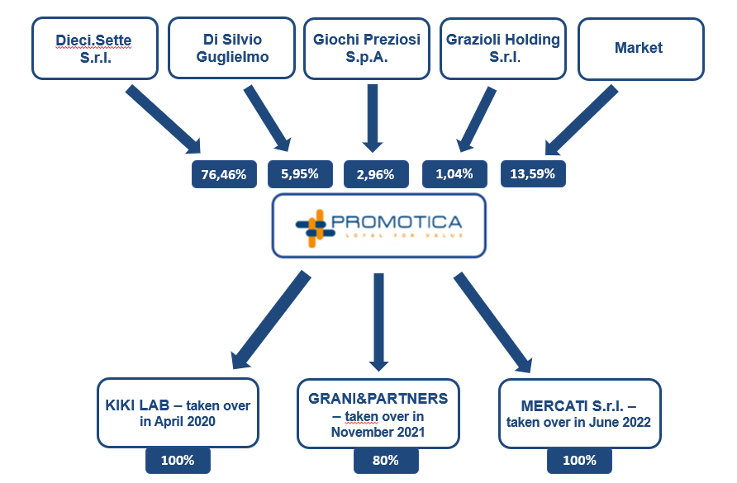

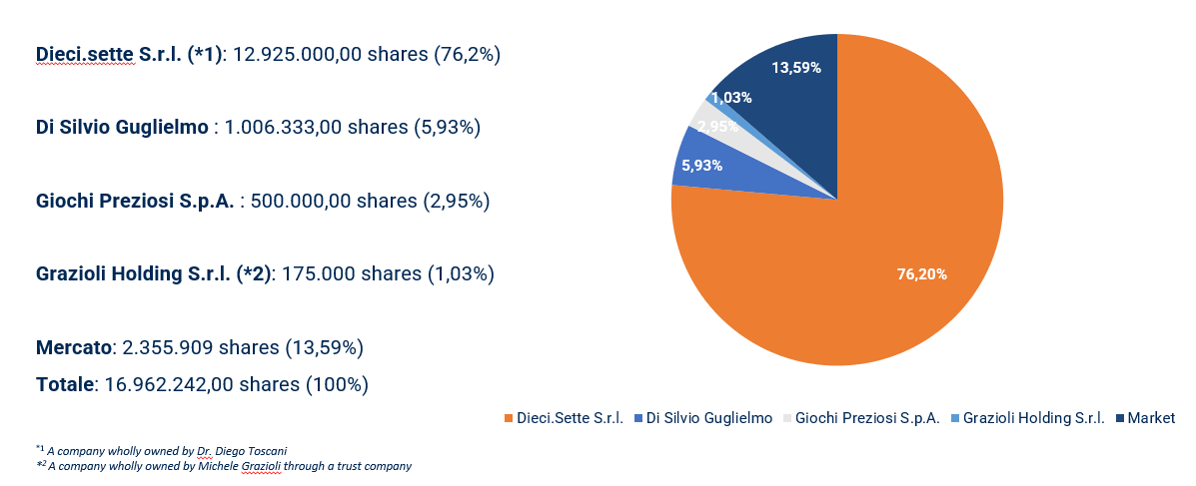

MANAGEMENT
Diego Toscani, Managing Director and Chairman of Board of Directors
After graduating in Business and Economics from Brescia University, Diego started working in commerce, gaining experience in Italian and foreign companies. He was Junior Marketing Manager for Groupe Couzon in Thiers (France) from 1996 to 1997, when he became Sales Manager at Pintinox S.p.A. in Sarezzo (BS), managing the retail and marketing channel. From 2000 until 2002, he was Sales Director at Recom S.p.A. in Trent. In 2003 he established Promotica, and thanks to his management strategy was able to expand the company significantly over the years until it was operating with 33 employees and 5 collaborators, achieving a turnover of €57.0 million in 2020.
From 2008 to 2014, he was also Chairman of ASVT S.p.A. (multi-utility sector), and has been a board member since 2009 at the company Better Side S.r.l (renewable sources).
Alongside his business activities, from 2014 to 2019 he was involved in politics as Mayor of Sarezzo in the province of Brescia.
He is also the Chairman of Easy Life S.r.l. (manufacture and sale of household goods) and board member at Vedrai S.p.A., a company specialising in the design and production of solutions based on artificial intelligence.
On 17 February 2022, he joined the board at AssoNext – the Italian Association of listed SMEs - as a director.
Finally, Diego Toscani holds a 55.59% share in Pozzi Milano, a company operating in the latest tableware and owner of the Pozzi and Castello Pozzi brands, listed on the Italian stock exchange's Euronext Growth Milan market since 19 July 2022.

July 2022
Copy by the CDR Communication press office

